The purpose of this analysis is to view the outcome of various Kickstarter Campaigns from around the world. This sample pool of data allows the client to see how various categories of the Kickstarter Campaigns compare. From this selected data set we were able to compare goals, pledge, timeframes, outcomes, and number of backers.

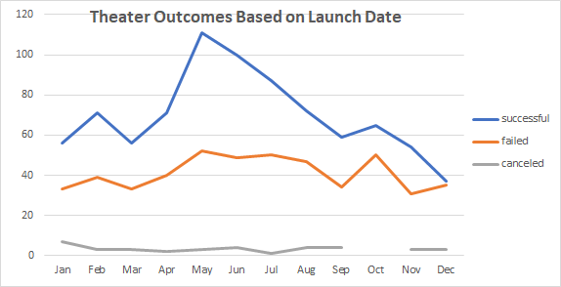 Looking at the various categories presented, we dug into the parent group of Theater. When we looked at the outcomes based on launch date for this category, I noticed that they had 1,369 campaigns start during the given year. The two months that had the most campaigns were May and June. During these two months, they also contained the most successful campaigns.

If we look at Outcomes based on Goals, you can see that successful campaigns make up just over half of the total campaigns. The bulk of these successful campaigns fell within the $1,000 - $4,000 range. Examining the higher amount (>$50K) campaigns, we can see that these make up only about 19% of the total projects.

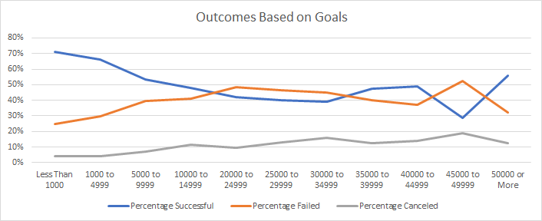

The data that was presented to us for this analysis, may not be giving us the best indication of each category. We are limited by the smaller sample sizes used to create this dataset. To get a better representation, a study over a longer period may be helpful. This would allow for a larger sample size and how the economy affects the successfulness of these campaigns.

We have many alternative ways we could view this data outside of the line graphs presented above. Bar graphs would generate a good visual for data from this dataset. We could generate bar graphs to show which categories produced the most campaigns or which countries are generating the most campaigns. We could use a graph to show the average donation per backer per country. This would be very help to use in future Kickstarter campaigns.